<https://www.cambly.com/en/student/courses/5e2b99e60b114e9a327ceb66/5e41bfccbabec89d4b531144>



Living Your Best Life

|  |  |  |
| --- | --- | --- |
| postmodifier  fire  fair | /ˌpəʊstˈmɒdɪfaɪə(r)/  /ˈfaɪə(r)/  /feə(r)/ equally, balance |  |
| hospice | /ˈhɒspɪs/ | a program of medical and emotional care for the terminally ill  The house take people going to die.  They will rethink what they have done in their life. |
| Elon Musk | /mʌsk/ | spaceX  Tesla /ˈteslə/ |
| Nikola Tesla |  | Famous inventor ɪnˈventə(r)/  Electrical engineer  Wireless lighting  Alternating current 交流电 |
| Edison | /ˈedis(ə)n/ |  |
| Charles Darwin | * /tʃɑːlz/ /ˈdɑːwɪn/ | Biological  Theory of biological evolution  《On the origin of Species》 |
| free will |  |  |

|  |  |  |
| --- | --- | --- |
| coolest | /ˈkuːlɪst/ | Good |
| fascinating | /ˈfæsɪneɪtɪŋ/ | Amazing  A fascinating story |
| fantasy | /ˈfæntəsi/ | imagination unrestricted by reality;  visional  Fancy  Illusion  imagine |
| imaginable | ɪˈmædʒɪnəbl/ | Possible  feasible |
| vacation | veɪˈkeɪʃn | holiday |
| meaningful |  | Worth /wɜːθ/ |
| invention | ɪnˈvenʃn/ | the creation of something in the mind |
| exercise my mind | /ˈeksəsaɪz/ |  |
| centimeters | sɛntɪˌmiːtəz/ |  |
| **daily routine** | /ˈdeɪli ruːˈtiːn/ | Daily routine 日常工作 |
| attire | /əˈtaɪə(r)/ | formal attire / cloth  clothing of a distinctive style or for a particular occasion 着装 |

1. For general, I think it means that people have a happy life and a great career.
2. For me, I think the living my best life includes a happy life, a steady job, a good health, and good hobbies.

You should try living the best life possible.

I just had the most delicious meal ever in my life.

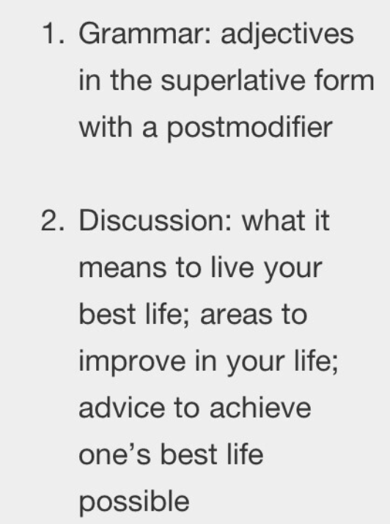

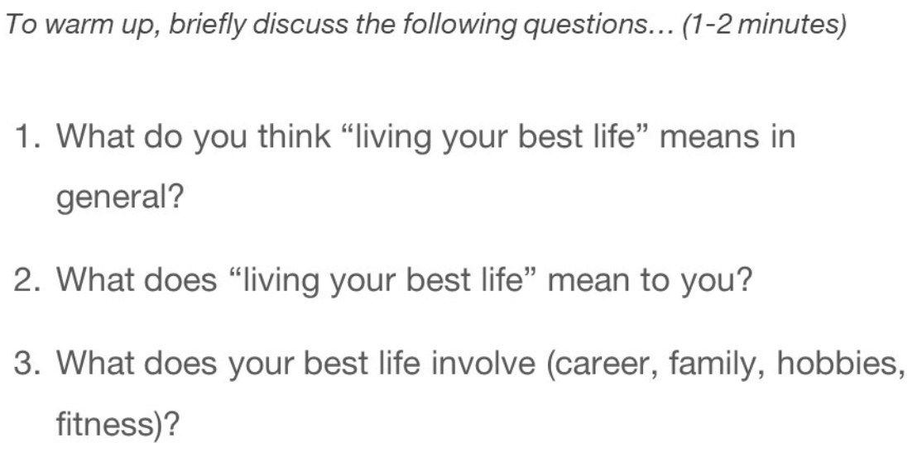

1. For general, I think it means that people have a happy life and a great career.
2. For me, I think the living my best life includes a happy life, a steady job, a good health, and good hobbies.

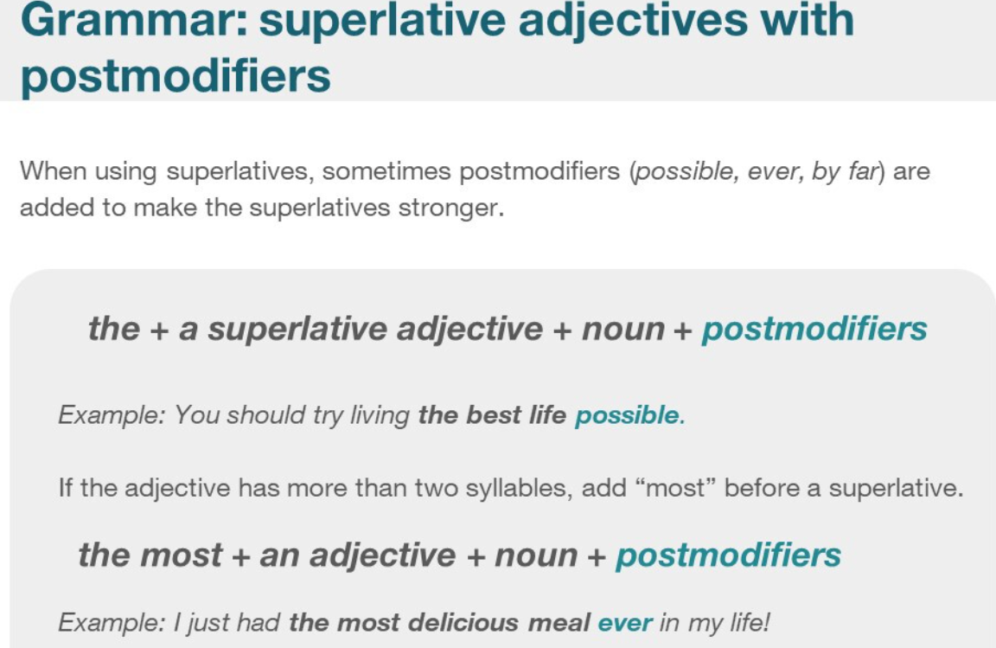

You should try living the best life possible.

I just had the most delicious meal ever in my life.

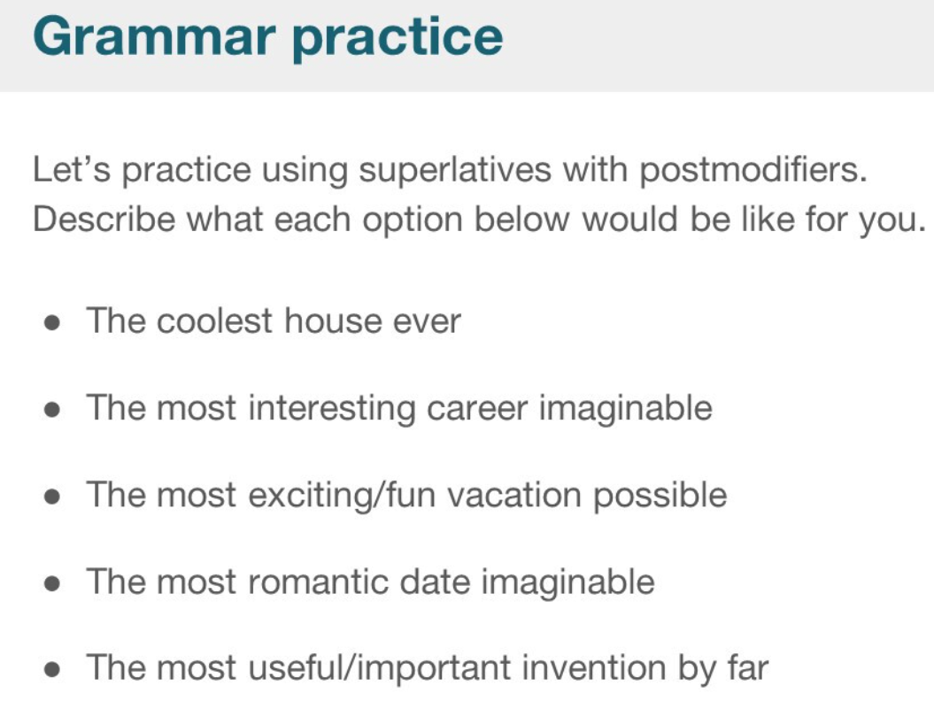

|  |  |  |
| --- | --- | --- |
| coolest | /ˈkuːlɪst/ | Good |
| fascinating | /ˈfæsɪneɪtɪŋ/ | Amazing  A fascinating story |
| imaginable | ɪˈmædʒɪnəbl/ | Possible  feasible |
| vacation | veɪˈkeɪʃn | holiday |
| meaningful |  | Worth /wɜːθ/ |
| invention | ɪnˈvenʃn/ | the creation of something in the mind |
| exercise my mind | /ˈeksəsaɪz/ |  |
| centimeters | sɛntɪˌmiːtəz/ |  |
| **daily routine** | /ˈdeɪli ruːˈtiːn/ | Daily routine 日常工作 |
| attire | /əˈtaɪə(r)/ | formal attire / cloth  clothing of a distinctive style or for a particular occasion 着装 |

